EXPERIMENTNO17

DeterminationandplottingofAntennaGainCalculation. Aim:
TodetermineandplotAntennaGain,andcalculatetheantennagain indBi

Softwarerequired:
- SCILABversion6.0.1

Program:
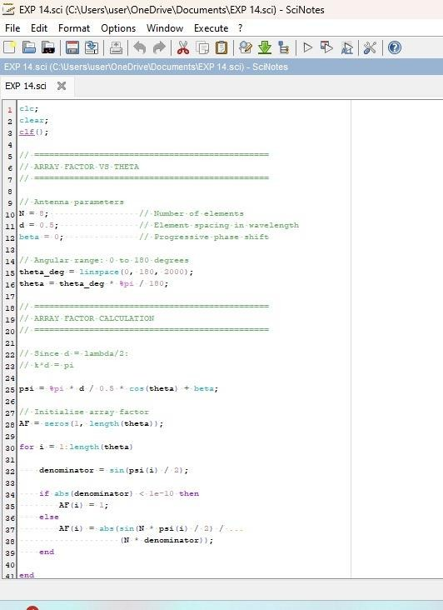

Output:
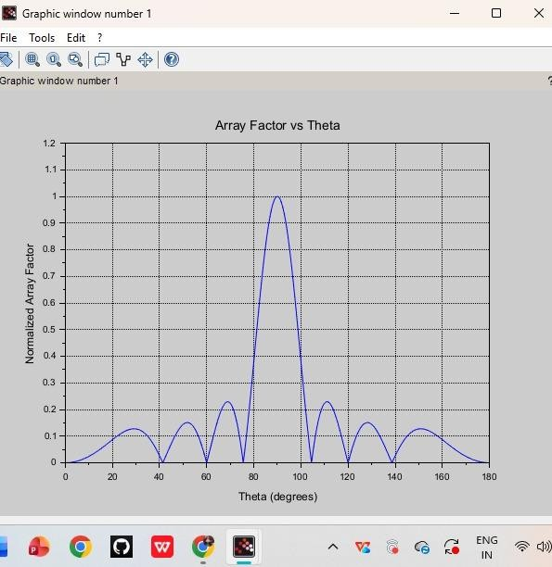

RESULT:Theexperimentwasdoneandthegaincalculationforthe givenantennawasdone.Differentcasestudieswereanalyzedand thegainwascalculated.

